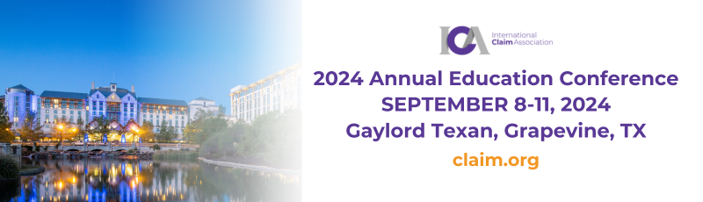

MARKETING TOOLKIT
We are pleased you will be participating in the 2024 ICA Annual Education Conference, September 8-11, 2024, in Dallas, TX. We encourage you to spread the word about your participation through your personal and professional social channels.

With two days of education and extended networking, attendees will have the opportunity to connect with colleagues and dive into dynamic sessions with industry experts, discover the latest trends and strategies, and expand your professional network. Visit https://www.claim.org/events/ica-2024-annual-education-conference-2/ for additional event details.

Event Links & Tags
We recommend tagging ICA’s social channels —@Claim.org (LinkedIn) — and using the hashtags #Dallas400 #ICA2024 and #ClaimEducation2024 when posting about the conference to increase the visibility of your company at the event.

Social Media Post Suggestions
[Company name] is [sponsoring the or exhibiting at the] upcoming 2024 ICA Annual Education Conference, September 8-11, 2024. Join us in Dallas and register to attend the event.
Images: https://www.claim.org/wp-content/uploads/2024/07/Were-Exhibiting-2-ICA2024.png
https://www.claim.org/wp-content/uploads/2024/07/Were-sponsoring-ICA2024-1.png

Excited to announce [company name] will be [sponsoring the or exhibiting at the] upcoming 2024 ICA Annual Education Conference, Join us at the event in Dallas, September 8-11.
Images: https://www.claim.org/wp-content/uploads/2024/07/Were-Exhibiting-2-ICA2024.png
https://www.claim.org/wp-content/uploads/2024/07/Were-sponsoring-ICA2024-1.png

Attending the 2024 ICA Annual Education Conference, September 8-11, 2024? Join [company name] at [booth number].
Image: https://www.claim.org/wp-content/uploads/2024/07/Im-attending-ICA2024.png

I’m speaking at the 2024 ICA Annual Education Conference, September 8-11, 2024. Join me at this unique event and dive into dynamic sessions with industry experts, discover the latest trends and strategies, and expand your professional network.
Image: https://www.claim.org/wp-content/uploads/2024/07/Im-speaking-ICA2024.png

Thrilled [company name] will be participating in the 2024 ICA Annual Education Conference. Register to attend the event, September 8-11, in Dallas.
Images: https://www.claim.org/wp-content/uploads/2024/07/Were-Exhibiting-2-ICA2024.png
https://www.claim.org/wp-content/uploads/2024/07/Were-sponsoring-ICA2024-1.png

[Company name] will be [sponsoring the or exhibiting at the] upcoming 2024 ICA Annual Education Conference and will [details about special offerings, giveaways and promotions]. Join us at the event. Images: https://www.claim.org/wp-content/uploads/2024/07/Were-Exhibiting-2-ICA2024.png
https://www.claim.org/wp-content/uploads/2024/07/Were-sponsoring-ICA2024-1.png

Grab a colleague and attend the 2024 ICA Annual Education Conference, September 8-11, in Dallas. [Company name] will be there.
Image: https://www.claim.org/wp-content/uploads/2024/07/Im-attending-ICA2024.png

Email Signature
To demonstrate your conference participation, you can include the image below in your email signature line by copying and pasting it into your signature directly. Once inserted into your signature, right click on the image, click “link,” paste https://www.claim.org/events/ica-2024-annual-education-conference-2/ into the “address” field, and click OK.





